OveOnboarding 101 Storyboard: Onboarding Basics

Onboarding 101 Speaker Notes | Onboarding 101 Presentation

SF Onboarding Intro Video/Storyline Interaction
Script | Visuals/Interactions on Screen
Welcome to SuccessFactors Onboarding 101. Please choose your location to begin. | Motion Graphic Intro (preview link)  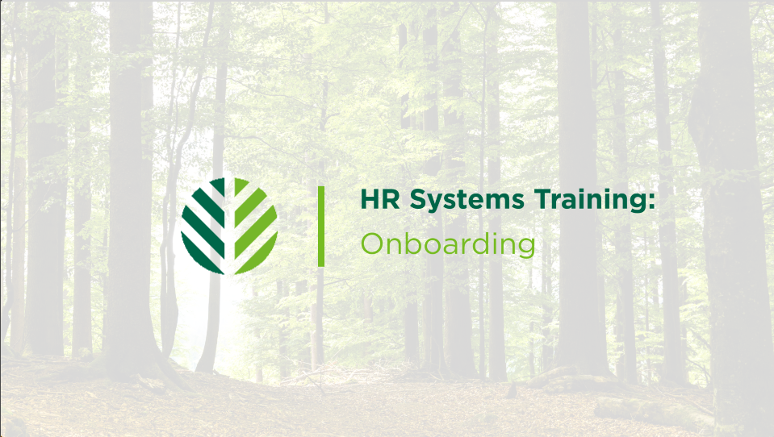  Cover Page: Cover page will have options of countries built into storyline and branch to the appropriate scene in story line. Countries will be illustrated by title and flag  ** Pending the international rollout, the only flags that will be available are the Canadian and American flags. Every other option will be grayed out. Content from the video will be designed in a way that video edits and additions can be added easily, the treatment below is unique to our US locations
Benefits of SF  The onboarding process is a critical part of getting new talent in the door here at GPI. Onboarding at GPI is a series of system tasks completed in SuccessFactors prior to an onboardee becoming a new hire. This is important to note because we often just think of onboarding as the onboardee’s overall experience, but here it also represents a workflow process.  The data collected during this process allows GPI to capture the lifecycle of our employees while they are at the company. This makes things like performance management, talent development, and total rewards easier for the company to track. Our end-to-end onboarding process is automated and tracked using the SuccessFactors Onboarding Module. SuccessFactors provides many benefits to both the onboardee and you as an HR professional.  For the onboardee, SuccessFactors creates a seamless experience by providing one place for them to reference the tasks they need to complete during onboarding. They receive reminders about compliance and regulatory documents and can also complete and sign the documents directly in the system.  For our HR community, SuccessFactors provides us with complete oversight of the entire process of transitioning a candidate into a new hire or as we know it, onboarding. It allows us to standardize the information that we collect from new hires based on work requirements; this new hire data allows GPI to have complete records for human capital management.  A positive onboarding experience creates a good first impression for our new employees and ultimately promotes retention. As a member of the HR community, you play a huge role in the success of our onboarding process. Let’s take a look at the roles that each person plays in the onboarding process...  **Add course objectives here | Video made largely with b-roll footage and generic screengrabs from SuccessFactors:  B-roll:  * Employee with name badge greeting someone in office  * Employee filling out forms/ video of generic forms being filled in  * Footage of group of GPI employees gathered at headquarters  * Footage of mill and plant workers talking  SuccessFactors Screengrabs:  - Scroll through the SuccessFactors onboarding dashboard HRBP view  - Scroll through the Onboarding Tasks from the onboardee view  - Scroll through compliance docs  - Screengrab of inputting employee data  Course objectives slide
Roles and Responsibilities in Onboarding  Click on each of the roles to learn about their responsibilities in the Onboarding process.  Talent Acquisition  - The TA representative initiates Onboarding process for salaried onboardees in SuccessFactors by completing the final steps in the Recruiting Module. This places the onboardee on the onboarding dashboard. (specify that this is the extent of TA involvement in SF onboarding... if that's true)  - Outside of SuccessFactors, The TA also assists in facilitating in integrating the new hire onto their team, into GPIs corporate culture, and into their specific role.  HRBP/HR Generalist  - The HR teams initiate Onboarding for hourly onboardees in SuccessFactors by finishing the ‘initiate onboarding’ in the Recruiting Module.  - Manage salaried onboarding tasks in the Onboarding Module.  - The HR teams facilitate the completion of official or required information & documents related to all hiring.  - The HR teams oversee this process to ensure all onboarding tasks are completed so the onboardee can be transitioned into a new hire.(HR teams should make sure that all tasks are completed prior to day one except Form I-9 section 2. This will confirm the attendance and identity if the onboardee.)  - Outside of SuccessFactors, the HRBP will manage the new hire orientation program and other resources to support onboarding.  Hiring Manager  - Hiring Managers will receive notifications in SuccessFactors for Onboarding tasks for their onboardees.  - Hiring Managers will organize onboarding, this includes activities for the first day, first week, first month, etc.  - Hiring Managers will also be responsible for reaching out to the onboardees and establishing regular communication  - Hiring Managers will need to help the New Hire assimilate into the GPI environment so that means connecting the new hire with key information, resources, and people.  - Hiring Managers will need to provide clear expectations, direction, coaching, and performance feedback during the Onboarding process  Onboardee (new definition 2 this training)  - Onboardees will review and complete all their assigned onboarding task(s) and ensure that all items are addressed in their entirety.  - Onboardees will be alerted if information is missing or if they need to provide additional documentation or detail.  - Onboardees will attend & actively participate in all scheduled onboarding or training activities as required by GPI or the Hiring Manager. | Click to reveal interaction (chevron drop downs that reveal bullet points that are read on the screen.):  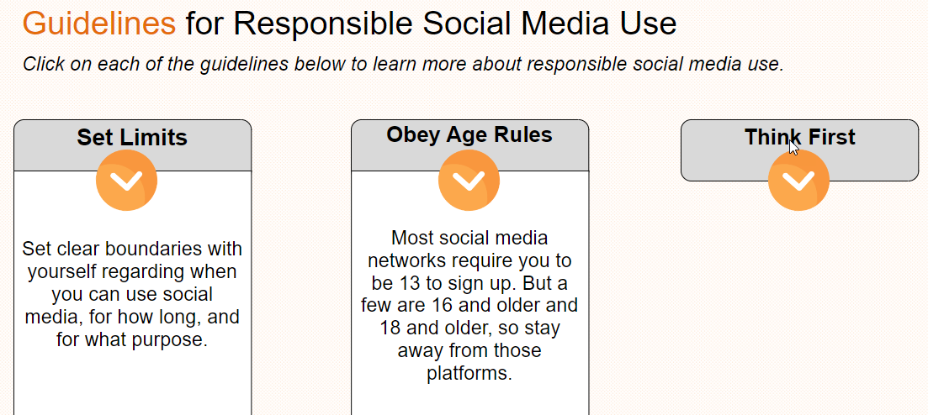
Knowledge Check  Statements:  - Responsible for initiating onboarding for hourly employees HR Team  - Receives notifications of onboardee’s tasks in SF. Hiring Manager, Onboardee , HR Team  - Candidate whose profile is moved from recruiting to onboarding after onboarding initiation Onboardee  - Benefits from complete oversight of the onboarding process in SuccessFactors. HR Team, Hiring Manager  - Responsible for initiating onboarding for salaried employees Talent Acquisition  - Is alerted if additional documentation or information is required for onboarding Onboardee  - Responsible for reaching out to the new hire and establishing communication. (Hiring Manager)  - Oversees the process to ensure everything is received from employee needed for hire (HR Team)  - Applicant who is still a candidate question...  - (placeholder) | The participant will have four choice boxes representing each of the roles. Statements will scroll across the screen to choose which role is responsible or which role matches a definition. Correct choices are required to advance.  Choices:  Talent Acquisition  HR Community  Hiring Managers  New Hire  The statements will be designed to reinforce the roles, responsibilities, and importance of onboarding that we want to highlight. .... Perhaps some statements have multiple correct answers?

Introduction to Onboarding Phases Interaction
(Introducing each section using the Demonstrate-Imitate-Repeat model)

Script | Visuals/Interactions on Screen
Let’s look at the Onboarding module in SuccessFactors so that you know your way around as we start learning. In case you want to follow along.  The Dashboard:  -Here is the dashboard. This is a good starting place for all onboarding activities. Employees that are moved to onboarding are assigned to an HR group so you may see onboardees that you didn’t interview. There are four sections of the dashboard: Data Collection, Form I-9 and E-Verify, Compliance Forms, and New Hire Tasks. For conformity, all the sections appear in the system globally, but only the applicable sections will populate data or require action. For example, the Form I-9 and E-Verify section appears for global teams but doesn’t require action anywhere but the US.  Completed Onboardee Profile:  This is what a complete profile looks like. Here you can see every section and the tasks that go with them. <what else do we say about the compelete>  Individual Employee Profile:  <what do we need to say here>  Next let’s look at process of onboarding at GPI and how you can manage it using the onboarding dashboard in SuccessFactors. Onboarding at GPI occurs in three major parts that encompass the sections on the onboarding dashboard: 1. New Hire (Onboardee) Info 2. Onboarding Forms 3. Submit for Hire. Some of these parts are represented as a section in the onboarding dashboard which lets you monitor each part's progress of completion. Also, some onboarding tasks must be completed to trigger another part of the onboarding process. For example, talent acquisition or the HRBP must initiate onboarding in the SuccessFactors recruiting module and confirm Onboardee info such as their name, position title, and start date before the onboardee receives the initial email to begin the onboarding process.  Let’s look at each ‘part’ of the process. We will overview the activities/tasks that occur in each part and which roles are responsible for them. At the end of each part, you will have a chance to walk through and simulate the actions you would need to take in SuccessFactors for practice. If it is not possible to build multiscorm packages in a way that hops in and out, then save this for the end and let it be one big case-based learning at the end. | 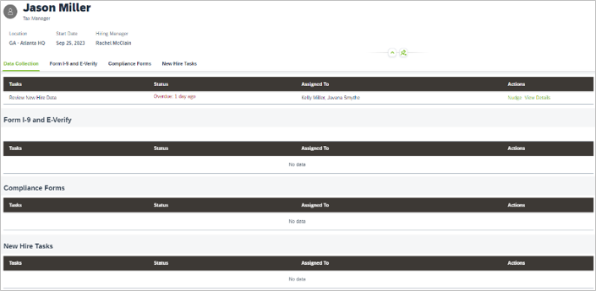  Use shots to capture examples of what you are describing in Success Factors:  - A shot of the dashboard where you can highlight the 3 sections that correspond to ‘parts’  - A flow chart that overviews the ‘activities’ that are happening at the same time in some of these parts... just a visual that shows it and it will be reinforced during the lesson  - b-roll footage to fill the rest.  The onboarding guide layout willl be used as the graphic that transitions into the *home screen* for each of the sections below:  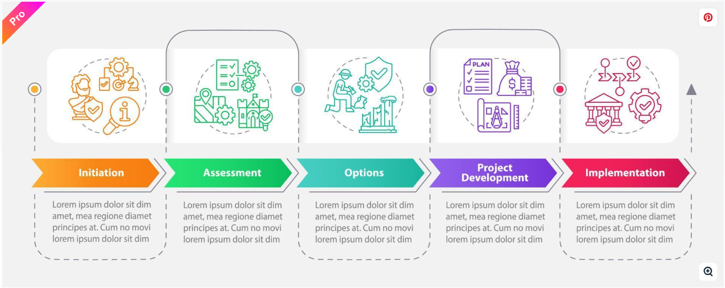  Design the onboarding guide layout so that pieces of that can be used as visuals and broll above  Check the SCORM capabilities and see what the best way is to organize the simulation.  j
Onboarding Initiation  (each section will also be a standalone video that can be hosted in MyHR)  The onboarding process can’t officially begin until the HRBP or Talent Acquisition initiator starts the process in the SuccessFactors recruiting module. A system notification alerts the responsible parties that a candidate is ready to be moved into onboarding once their recruitment profile has been placed in the ‘move to onboarding’ phase. The responsible party will then be responsible for using the ‘Initiate Onboarding’ option to start the onboarding process. HRBPs and Talent Acquisition can view all new hires in the onboarding dashboard based on their location. The initiators will only have access to new hires that they are associated with. It is important to remember that locations are clustered so everyone in your HRBP group will be able to see onboardees for your location, not just the one listed on the job requisition. Virtual locations get assigned to PSS.  Once the appropriate initiator selects ‘initiate onboarding’ in the recruitment module the onboardee will be visible on the onboarding dashboard. For rehires there is an extra verification that occurs when based on certain data fields. Rehires will not appear until that verification has occured.  Rehire verification is an automatic thing when certain data fields match and the new hire won’t appear on the dashboard until that occurs.  Let’s use Luke’s Profile from the recruiting module training to walk through the process of onboarding in successfactors. | - Higlight screenshot of the system notification that a candidate is ready to move to onbaording  - Screenshot of the recruiting module area that says “initiate onboarding  - Screenshot of the onboarding dashboard with some employees ready to start onboarding. (may need to create multiple ficitional characters for the modules)  - On the onboarding dashboard screenshot, highlight each of the sections on the dashboard as they are being described.  After this interaction or video concludes. Immediately move back to the home page and have the visited section grayed out have forced navigation.
Part 1: New Hire Data Collection (New Hire Info)  What are the clicks and keystrokes of this section for our audience  The first part of the onboarding process is when the new hire provides and verifies their personal data. This begins with the HRBP or TA reviewing and verifying the data that transfers over from the recruiting profile. This part is mostly a review of position management information and employee data. The reviewer will check the following:  - The hire date <provide context>  - The proper personal email <provide context>  - A phone number <provide context and explain proper formatting..i.e. use the dashes>  - The correct position information (number, title cost center) Some situations may call for you to recruit using a filled position or one from another department. You want to make sure that the position number you are going to use has no overlap and that the cost center associated with it is correct.  Once this information is validated in SuccessFactors, the reviewer can select (submitting automatically kicks off to the next step) to initiate the tasks that are assigned to the new hire.  First, a system generated welcome email is sent to the new hire. ((you can click the icon to see a pop out of the system generated email)) | Each section with a video can have a video that begins with a click into that part of the onboarding dashboard  Start with a new hire image and bulleted list.  Create system demos on a clickable layer in the video (or automatically triggered) so that if processes or the view of the system changes you can go back in and update it easily.  Create an icon on the page that will do a lightbox slide of the system generated email.
The welcome email will provide the new hire with instructions for creating a system password for SuccessFactors. Once the new hire has access to the system, they will have a dashboard of tasks to complete that are aligned with the parts of onboarding.  Mention WOTC- condensed fact sheet  The onboardee will be instructed to provide and verify their personal information, complete the required tax forms, and complete regulatory and compliance forms.  This onboardee will provide or verify the following personal information:  - Name (Preferred)  - Address  - DOB  - SSN  - Contact Information & Emergency Contact  - Direct Deposit and Payment information  The onboardee will be prompted to double check the information provided here because once this information is submitted, it becomes a part of GPI records and will require HR assistance to change (DOB SSN and Name—stuff we send to govt). If any of the information is incorrect, the employee can decline the esignature and reopen the information to edit.  The onboardee will also fill in their tax documents and compliance forms like the GPI policies and sign with an e-signature.  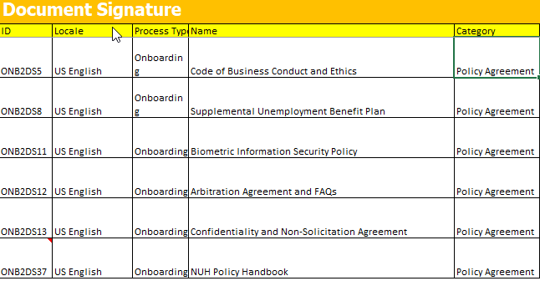  Once the compliance forms and personal information are entered and confirmed, the onboardee could technically be hired into the system as an employee--- Reword to: once the verify e-signature step and GPI policy documents can be submitted for hire. You can also send a nudge to employees to remind them to complete these tasks if necessary. | This audio will play over a video of the fictious character entering this information into the system.  Do a video overlay of the bullet points  Get a screenshot of the prompt to double check documents before submission and use visual elements to stress the double check.  Visually represent the best practice of waiting until day 1 to hire in the system. (Prepare to use this visual throughout the onboardin lessons.)
Part 2: Onboarding Forms  Show the emails that Luke will get and what they will experience from start to finish- dont put time frame on the language so that it can apply to the masses.  - Welcome email. Steps to get set up in the system  - WOTC*  - Show the onboarding process in SF  - I-9 Email Alert and a WOTC reminder. Triggers after the first set of steps are complete.  - Filling out the I9 in the system/Outstanding  E-Verify and Compliance Documents are sections on the onboarding dashboard because they each have tasks to complete before an onboardee can be hired into the system. We will refer to these as the onboarding forms. The employee receives these as tasks on their dashboard along with filling out their personal information. Let’s take a closer look at each one  E-verify is an electronic process of confirming an employee's eligibility to work in the U.S. We have integrated it into the onboarding process to make it seamless for the onboardee.  The I-9 forms are broken into two sections that gather information to ensure that employees are legally authorized to work in the U.S. It is a federal requirement that GPI keep I9 records updated and SuccessFactors helps us do this. Section 1 of the I9 is what the employee fills in while filling in the personal information. Section 2 of the I9 will be completed by the HRBP after section 1 is done. An e-verify case to review this section is automatically created in the system after the HRBP submits section 2. Each e-verify case will be assigned a case verification number and case results. The case results can be viewed on the onboarding dashboard.  It is important to note that if there are any errors in the information that the onboardee provides, you will need to correct this information and send it back to the onboardee to confirm the changes. Errors commonly occur with DOB and SSN entry. ((We will look at Luke putting something in wrong))  HRBP role.  - Tile that pops up for section 2  - Show the onboarding dashboard and see the different statuses based on tasks  - Walk through section 2 form  - Walk through everify.  Section 2 receipts? 101 or 102? | .
New Hire Tasks

You can customize your onboardee’s onboarding experience by adding unique ‘new hire tasks’ to the dashboard. These tasks and activities can be curated to help welcome and integrate new hires into GPI and your area. HR teams can manage and track these tasks through SuccessFactors. Some examples of this include:

- A personalized welcome message
- Recommending people for the new hire to connect with
- Recommended links for the new hire
- A Day 1 preparation list

There is a default checklist provided so that the Hiring manager or HRBP can prepare for the new onboardee’s first day. You can add, delete, and delegate any checklist item.

((Let’s add some tasks for for before Luke’s first day))

Moving toward removing this functionality – do we still train to it?
. Part 3: Submit for Hire  The final part of onboarding is converting the onboardee to a hire in the system. This conversion process serves a few important purposes:  - It integrates the employee data that has been gathered into the system—The personal details, job information and payroll information become official GPI employee record  - It is used to signify that the tasks, forms, and approvals, associated with onboarding have been completed – this is a signal that the employee has gone through the necessary steps like signing contracts and submitting necessary documents and is ready to hire.  - It hires them into the system and officially begins their employee history with the company—until the conversion task is complete, the onboardee is still external to the company. Once the conversion happens, the system can start capturing historical events like performance evaluations, promotions, and other HR processes.  After the onboardee completes all their esignatures on the company forms, they will appear in the system as ready to convert. However, It is very important that you make sure they have completed the compliance forms before hiring them into the system. Converting an onboardee to hire occurs on the Manage Pending Hire page in SuccessFactors. You will be able to view all the pending hires by searching for this page from the homepage or through the onboarding page.  - Show section 2  - Show submit for hire. | Create system demos on a clickable layer in the video (or automatically triggered) so that if processes or the view of the system changes you can go back in and update it easily.
I would like to develop a scenario that runs through recruiting and onboarding using a fictional character. I want to use this as an opportunity to present common mistakes and give the participant a chance to practice navigating them ((these will be like situations that we ran through with ‘Luke’ but it gives them a chance to practice after having watched.

-incorrect DOB/SSN
-password reset

** is there anything in particular that should be said as a conclusion?? I’m not too sure/”.

